SELF-REFLECTION EXERCISE
Topics: self-care, keeping self-care journal

SELF-CARE IS NOT SELFISH

When a baby is born, it is a big change for parents, the mother becomes "invisible" and the father very often becomes less important in wife’s life. The baby and its needs are the focus of attention of the immediate environment and the mother herself. Of course, there is nothing wrong or inappropriate about this. Important and pivotal life moments, such as just the arrival of a new family member, are always accompanied by an imbalance. It is important to notice this imbalance and develop a new harmony. In order to avoid parental burnout it is important to practice self-care.

SELF-REFLECTION EXERCISE

What were your self-care practices before you had child/children? Can you implement any of them now while being a parent? Below you can find examples of self-care activities.
List your self-care ideas and for one month note in your calendar how much time per day/week you dedicate to yourself.
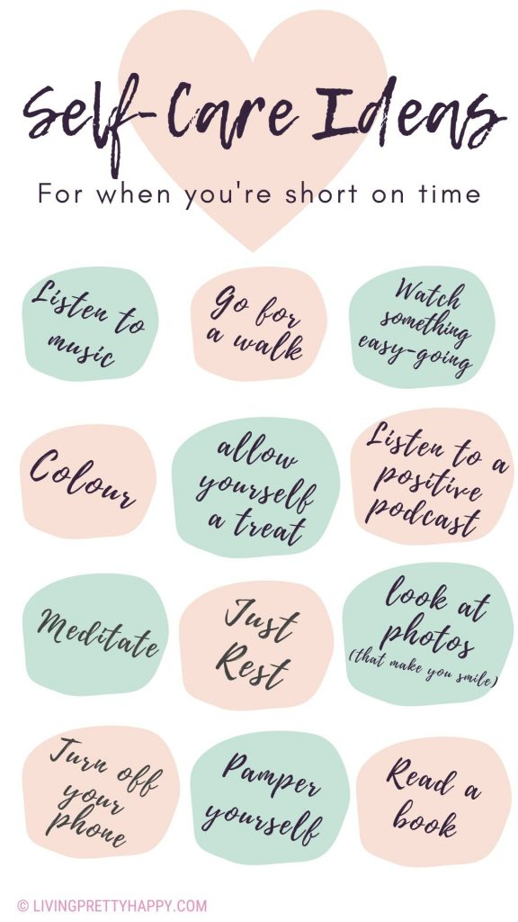
Source:https://livingprettyhappy.com/2020/03/25/maintain-self-care-for-parents-during-lockdown/

